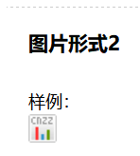
<script type="text/javascript">var cnzz_protocol = (("https:" == document.location.protocol) ? " https://" : " http://");document.write(unescape("%3Cspan id='cnzz_stat_icon_1274389804'%3E%3C/span%3E%3Cscript src='" + cnzz_protocol + "s13.cnzz.com/z_stat.php%3Fid%3D1274389804%26show%3Dpic1' type='text/javascript'%3E%3C/script%3E"));</script>

________________________________________________________________________________________

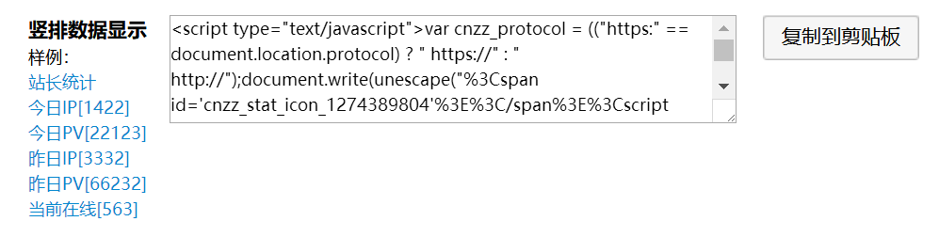
<script type="text/javascript">var cnzz_protocol = (("https:" == document.location.protocol) ? " https://" : " http://");document.write(unescape("%3Cspan id='cnzz_stat_icon_1274389804'%3E%3C/span%3E%3Cscript src='" + cnzz_protocol + "s13.cnzz.com/z_stat.php%3Fid%3D1274389804%26online%3D1' type='text/javascript'%3E%3C/script%3E"));</script>

_______________________________________________________________________________________________
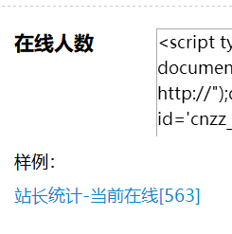
<script type="text/javascript">var cnzz_protocol = (("https:" == document.location.protocol) ? " https://" : " http://");document.write(unescape("%3Cspan id='cnzz_stat_icon_1274389804'%3E%3C/span%3E%3Cscript src='" + cnzz_protocol + "s13.cnzz.com/z_stat.php%3Fid%3D1274389804%26online%3D2' type='text/javascript'%3E%3C/script%3E"));</script>

